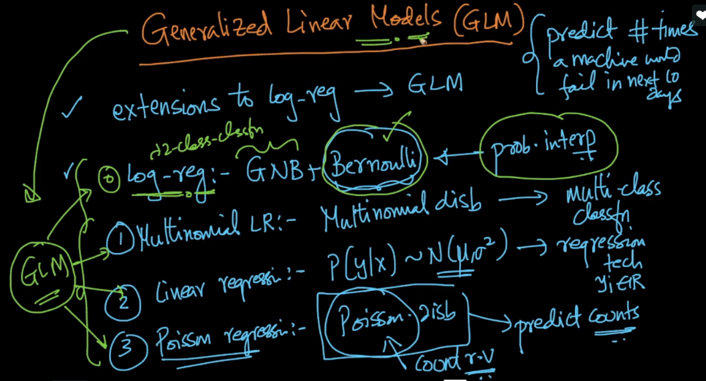

As logistic regression = GNB + Bernouli dist(y).

So just by changing distribution of output Y we can make several other generalized model.

**Multinomial LR :** In this y would be multinomial that means there are more than 2 classes to be classified.

**Linear Regression:** where Y belongs to guassian distribution.

**Poison regression:** where Y is poison distribution (poision dist is basically count, ex: how many times machine will fail, or how many times volcano will erupt etc). It’s used when we’ve to predict counts.

Refer part 3 of this pdf <http://cs229.stanford.edu/notes/cs229-notes1.pdf> to know how generalization helps in generating models mathematically. Do it only interested in Math otherwise can leave it.

Comments:



